STATISTICAL ANALYSIS AND PREDICTIVE MODELING USING R

Week 3 – Task 3

Retail Store Sales Dataset
Statistical Analysis, Hypothesis Testing and Multiple Linear Regression
Prepared by:
Aashin N

1. Task Objective
The objective of this task was to conduct statistical analysis and develop a predictive model using R. The analysis extends the work completed during Tasks 1 and 2 using the same Retail Store Sales dataset.
Task 1 focused on data cleaning, preprocessing, missing-value treatment, transformation, encoding and preliminary exploratory analysis. Task 2 extended the analysis through data visualization to identify patterns in product categories, transaction values, sales locations, payment methods and monthly sales.
Task 3 builds upon these stages by applying inferential statistical techniques and predictive modeling. The analysis includes hypothesis testing, correlation analysis, normality assessment, multiple linear regression, train-test evaluation, 10-fold cross-validation and regression diagnostics.
The primary predictive objective was to investigate whether transaction-level characteristics could be used to predict Total Spent. Particular attention was given to Quantity and Price Per Unit, as previous exploratory analysis indicated strong relationships between these variables and transaction value.

2. Dataset Identification and Rationale
The Retail Store Sales dataset used in Tasks 1 and 2 was retained for Task 3 to maintain consistency across the overall project.
After the cleaning and preprocessing performed during Task 1, the dataset contained:
- 11,971 observations
- 18 variables
- Numerical variables such as Price Per Unit, Quantity and Total Spent
- Categorical variables such as Category, Payment Method, Location and Discount Applied
- Additional transformed and encoded variables generated during preprocessing
The dataset was suitable for statistical and predictive analysis because it contains both numerical and categorical variables, allowing several statistical techniques to be investigated.
Total Spent was selected as the target variable for regression analysis because it represents the monetary value of an individual transaction and is directly relevant to retail sales analysis.
An important characteristic of the dataset is that Total Spent is mathematically related to Price Per Unit and Quantity. This relationship was considered carefully during model development and interpretation to avoid presenting deterministic relationships as evidence of unusually strong general predictive capability.

3. Loading and Verifying the Dataset
The cleaned dataset from Task 1 was loaded into R and inspected before statistical analysis.
library(readr)
library(ggplot2)

clean_data <- read_csv(
"cleaned_data/cleaned_retail_store_sales.csv",
show_col_types = FALSE
)

dim(clean_data)
str(clean_data)
The dataset contained:
11971 observations
18 variables
Summary statistics were then examined for the primary numerical variables.
summary(clean_data[c(
"Price.Per.Unit",
"Quantity",
"Total.Spent"
)])
The resulting descriptive statistics were:
Variable | Minimum | Q1 | Median | Mean | Q3 | Maximum
Price Per Unit | 5.00 | 14.00 | 23.00 | 23.36 | 33.50 | 41.00
Quantity | 1 | 3 | 6 | 5.536 | 8 | 10
Total Spent | 5.00 | 51.00 | 108.50 | 129.70 | 192.00 | 410.00
The difference between the mean and median of Total Spent suggested that its distribution was not perfectly symmetric. This was investigated further through formal normality testing.

Dataset summary
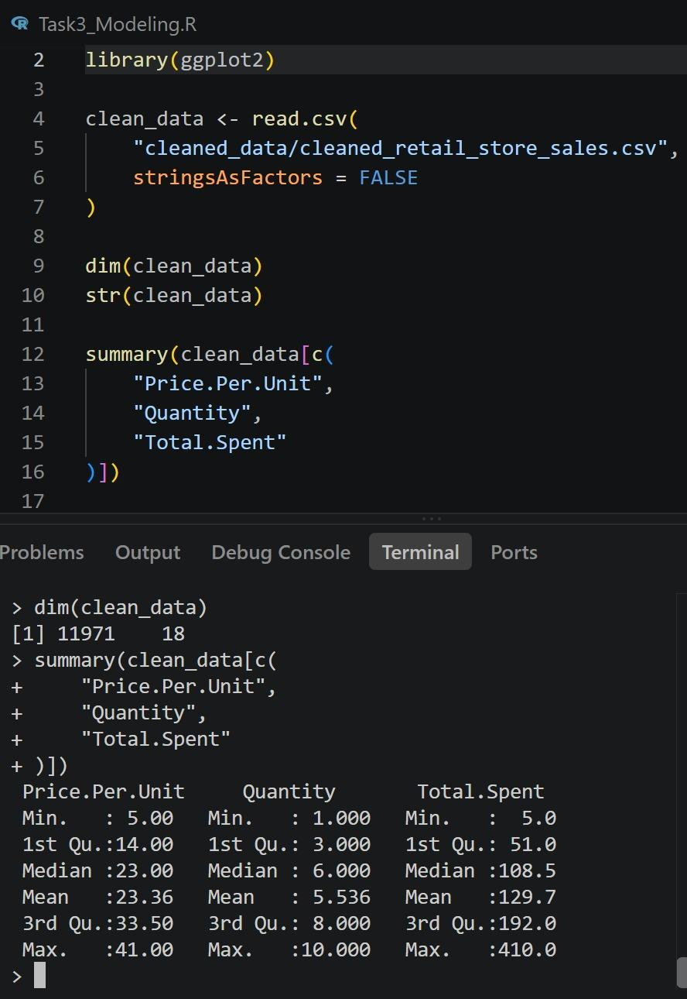
Figure: Initial dataset dimensions and summary statistics for the primary numerical variables.

4. Exploratory Statistical Analysis

4.1 Pearson Correlation: Quantity and Total Spent
A Pearson correlation test was conducted to examine the linear relationship between Quantity and Total Spent.

Hypotheses
H₀: There is no significant linear correlation between Quantity and Total Spent.
H₁: There is a significant linear correlation between Quantity and Total Spent.
The following R code was used:
cor.test(
clean_data$Quantity,
clean_data$Total.Spent,
method = "pearson"
)

Results
Pearson's product-moment correlation

t = 110.95
df = 11969
p-value < 2.2e-16

95 percent confidence interval:
0.7031242 to 0.7207887

Correlation = 0.7120691

Interpretation
The Pearson correlation coefficient was approximately 0.7121, indicating a strong positive linear association between Quantity and Total Spent.
The p-value was below 0.05; therefore, the null hypothesis was rejected.
There is statistically significant evidence of a positive linear relationship between Quantity and Total Spent. Transactions involving larger quantities generally have higher total transaction values.
The 95% confidence interval ranged from approximately 0.7031 to 0.7208 and did not contain zero, providing additional evidence of a positive relationship.

4.2 Pearson Correlation: Price Per Unit and Total Spent
A second Pearson correlation test examined the relationship between Price Per Unit and Total Spent.

Hypotheses
H₀: There is no significant linear correlation between Price Per Unit and Total Spent.
H₁: There is a significant linear correlation between Price Per Unit and Total Spent.
cor.test(
clean_data$Price.Per.Unit,
clean_data$Total.Spent,
method = "pearson"
)

Results
t = 88.895
df = 11969
p-value < 2.2e-16

95 percent confidence interval:
0.6197029 to 0.6412856

Correlation = 0.6306162

Interpretation
The Pearson correlation coefficient was approximately 0.6306, demonstrating a moderately strong positive relationship between Price Per Unit and Total Spent.
Since the p-value was below 0.05, the null hypothesis was rejected.
Therefore, there is statistically significant evidence that transactions containing higher-priced products tend to have higher total transaction values.
Comparing the two correlations showed that Quantity had the stronger individual linear association with Total Spent:
- Quantity and Total Spent: r = 0.7121
- Price Per Unit and Total Spent: r = 0.6306
Both variables were therefore considered important candidates for predictive modeling.

4.3 Normality Analysis
The distribution of Total Spent was examined using the Shapiro-Wilk normality test.
Because the complete dataset contained 11,971 observations and R's shapiro.test() function accepts a maximum of 5,000 observations, a reproducible random sample of 5,000 Total Spent values was selected.
set.seed(123)

total_spent_sample <- sample(
clean_data$Total.Spent,
5000
)

shapiro.test(total_spent_sample)

Hypotheses
H₀: Total Spent follows a normal distribution.
H₁: Total Spent does not follow a normal distribution.

Results
Shapiro-Wilk normality test

W = 0.92517
p-value < 2.2e-16

Interpretation
The p-value was significantly below 0.05, resulting in rejection of the null hypothesis.
The sampled Total Spent values therefore showed statistically significant evidence of non-normality.
This result was consistent with the histogram created during Task 2, which showed that transaction values were right-skewed.
However, non-normality of the dependent variable alone does not automatically prevent the use of linear regression. For linear regression inference, the distribution and behavior of the model residuals are particularly important. Residual diagnostics were therefore performed after fitting the regression model.

4.4 Hypothesis Test: Total Spent by Purchase Location
A Welch two-sample t-test was conducted to determine whether the average Total Spent differed significantly between Online and In-store transactions.
First, average Total Spent was calculated for each location.
aggregate(
Total.Spent ~ Location,
data = clean_data,
FUN = mean
)
The results were:
Location | Mean Total Spent
In-store | 128.8616
Online | 130.4221

Hypotheses
H₀: Mean Total Spent is equal between Online and In-store transactions.
H₁: Mean Total Spent differs between Online and In-store transactions.
The Welch t-test was conducted using:
t.test(
Total.Spent ~ Location,
data = clean_data
)

Results
t = -0.90082
df = 11958
p-value = 0.3677

95 percent confidence interval:
-4.955949 to 1.835040

Interpretation
Online transactions had a slightly higher mean transaction value of 130.42, compared with 128.86 for In-store transactions.
However, the p-value of 0.3677 was greater than 0.05. Therefore, the null hypothesis was not rejected.
There was insufficient statistical evidence to conclude that mean Total Spent differed significantly between Online and In-store transactions.
This provides an important extension to the Task 2 visualization results. Task 2 showed that Online transactions generated greater total revenue, but Task 3 demonstrates that this does not necessarily mean that individual Online transactions had significantly greater average values.
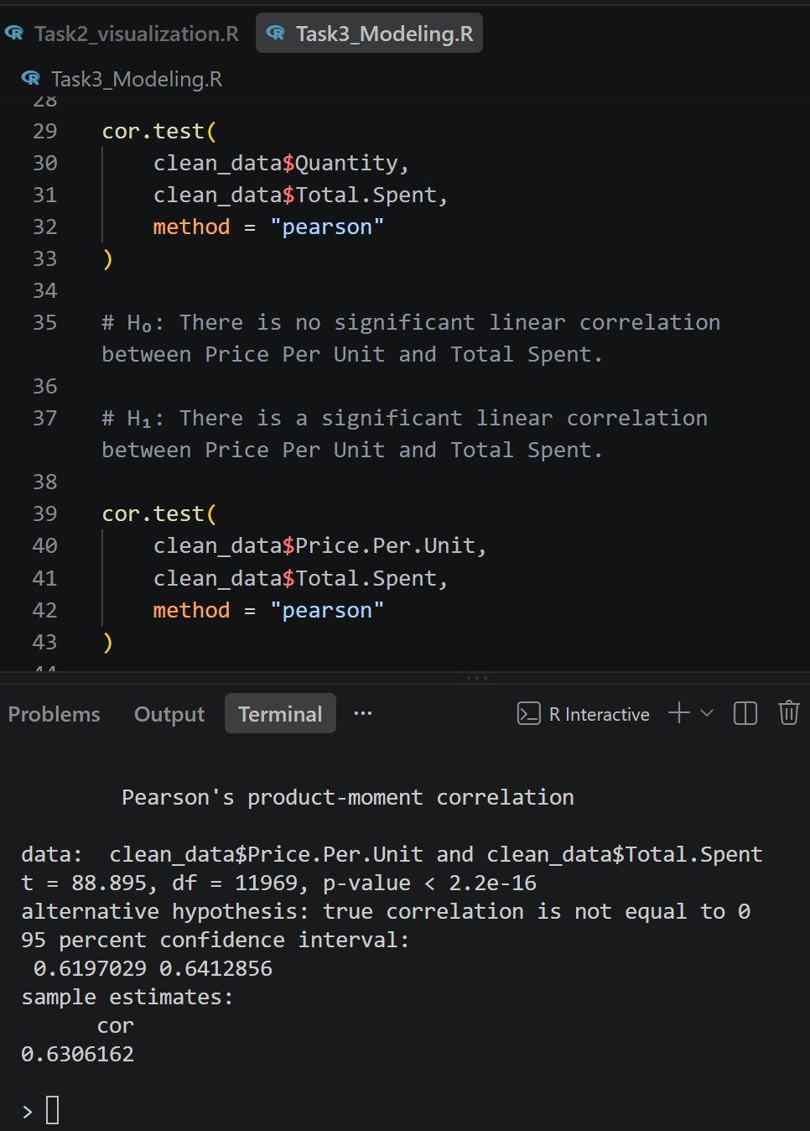
Figure: R output for correlation, normality, and group-comparison hypothesis tests.

5. Predictive Modeling

5.1 Prediction Objective
The predictive modeling stage aimed to estimate Total Spent using transaction-level characteristics.
The initial multiple linear regression model included:
- Quantity
- Price Per Unit
- Location
- Payment Method
- Discount Applied
- Product Category
The model was developed in two stages.
Model 1 used an additive linear structure.
Model 2 introduced an interaction between Price Per Unit and Quantity to investigate whether the initial model could be improved by representing their combined effect.

5.2 Training and Test Split
The dataset was divided into training and test datasets using an approximately 80/20 split.
A random seed was specified to ensure reproducibility.
set.seed(123)

train_index <- sample(
seq_len(nrow(clean_data)),
size = 0.80 * nrow(clean_data)
)

train_data <- clean_data[train_index, ]
test_data <- clean_data[-train_index, ]

dim(train_data)
dim(test_data)
The resulting datasets contained:
Training data: 9576 observations
Testing data: 2395 observations
Approximately 80% of the observations were therefore used for model development, while approximately 20% were retained as unseen test data for final evaluation.
Categorical variables were converted into factors before modeling.
train_data$Category <- factor(train_data$Category)
train_data$Location <- factor(train_data$Location)
train_data$Payment.Method <- factor(train_data$Payment.Method)
train_data$Discount.Applied <- factor(train_data$Discount.Applied)
Equivalent factor levels were maintained in the test dataset.

6. Model 1 – Additive Multiple Linear Regression
The first regression model used an additive specification:
model_1 <- lm(
Total.Spent ~
Quantity +
Price.Per.Unit +
Location +
Payment.Method +
Discount.Applied +
Category,
data = train_data
)

summary(model_1)
The model assumes that each predictor contributes additively to the predicted Total Spent.

Model 1 Summary
Important results included:
Residual standard error = 30.55

Multiple R-squared = 0.8961
Adjusted R-squared = 0.8959

F-statistic = 5889
p-value < 2.2e-16

Interpretation
The training R² of 0.8961 indicates that Model 1 explained approximately 89.61% of the variation in Total Spent.
The adjusted R² was approximately 0.8959, which was very close to the ordinary R² and indicated that the model retained substantial explanatory power after accounting for the number of predictors.
The overall regression F-test was highly statistically significant with a p-value below 2.2e-16.
Quantity and Price Per Unit were particularly important predictors.
For Quantity:
Estimate = 23.4335
p-value < 2e-16
For Price Per Unit:
Estimate = 5.4972
p-value < 2e-16
Both were highly statistically significant.
Location, Payment Method and Discount Applied were not statistically significant at the conventional 0.05 level in this additive model.
Some category coefficients were statistically significant relative to the model's reference category. However, these individual dummy-variable coefficients were interpreted cautiously because category effects depend on the selected reference level and the other predictors included in the regression.

7. Test-Set Model Evaluation
Predictions were generated using the previously unseen test dataset.
pred_model1 <- predict(
model_1,
newdata = test_data
)
Three performance metrics were calculated:
- Root Mean Squared Error (RMSE)
- Mean Absolute Error (MAE)
- R-squared (R²)

Model 1 Test Results
RMSE = 30.9746
MAE = 23.1266
R² = 0.8935

Interpretation
Model 1 explained approximately 89.35% of the variation in Total Spent within the test dataset.
The RMSE of approximately 30.97 indicates the magnitude of prediction errors while placing greater weight on larger errors.
The MAE of approximately 23.13 indicates that predictions differed from actual Total Spent values by approximately 23 monetary units on average.
The similarity between the training R² of 0.8961 and test R² of 0.8935 suggested that Model 1 maintained similar predictive performance when applied to unseen observations.

8. 10-Fold Cross-Validation
To assess whether model performance was stable across different subsets of the data, 10-fold cross-validation was performed on the training dataset.
The training data was divided into ten approximately equal folds. During each iteration, nine folds were used to train the model and the remaining fold was used for validation.
This process was repeated until each fold had been used once for validation.
set.seed(123)

folds <- sample(
rep(1:10, length.out = nrow(train_data))
)

cv_rmse <- numeric(10)
cv_mae <- numeric(10)
cv_r2 <- numeric(10)

for (i in 1:10) {

cv_train <- train_data[folds != i, ]
cv_valid <- train_data[folds == i, ]

cv_model <- lm(
Total.Spent ~
Quantity +
Price.Per.Unit +
Location +
Payment.Method +
Discount.Applied +
Category,
data = cv_train
)

cv_pred <- predict(
cv_model,
newdata = cv_valid
)

cv_rmse[i] <- sqrt(
mean((cv_valid$Total.Spent - cv_pred)^2)
)

cv_mae[i] <- mean(
abs(cv_valid$Total.Spent - cv_pred)
)

cv_r2[i] <- 1 - (
sum((cv_valid$Total.Spent - cv_pred)^2) /
sum(
(cv_valid$Total.Spent -
mean(cv_valid$Total.Spent))^2
)
)
}

Cross-Validation Results
Fold | RMSE | MAE | R²
1 | 29.678 | 22.052 | 0.8991
2 | 31.253 | 23.501 | 0.8920
3 | 31.140 | 23.380 | 0.8926
4 | 30.877 | 23.235 | 0.9035
5 | 31.588 | 23.691 | 0.8913
6 | 29.698 | 22.086 | 0.8943
7 | 30.486 | 23.025 | 0.8911
8 | 30.204 | 22.815 | 0.8982
9 | 29.660 | 21.914 | 0.8972
10 | 31.047 | 23.335 | 0.8970
The average cross-validation performance was:
Average RMSE = 30.5632
Average MAE = 22.9034
Average R² = 0.8956

Interpretation
The cross-validation results were relatively consistent across all ten folds.
Average cross-validation R² was approximately 0.8956, while test-set R² was approximately 0.8935.
Similarly:
Metric | 10-Fold CV Average | Test Set
RMSE | 30.5632 | 30.9746
MAE | 22.9034 | 23.1266
R² | 0.8956 | 0.8935
The close agreement between cross-validation and test-set performance indicates that Model 1's predictive results were relatively stable and were not dependent on a single favorable train-test split.

9. Regression Diagnostic Analysis
Regression diagnostics were conducted to assess the assumptions and limitations of Model 1.
The four standard diagnostic plots were generated using:
par(mfrow = c(2, 2))

plot(model_1)

par(mfrow = c(1, 1))
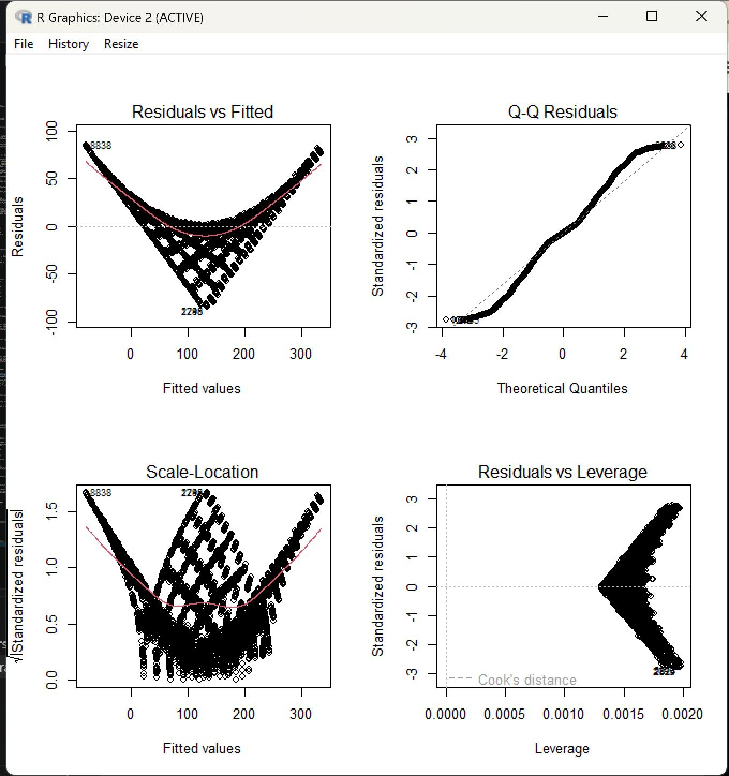
Figure 1. Regression diagnostic plots for Model 1

9.1 Residuals vs Fitted
The Residuals vs Fitted plot showed a pronounced curved pattern rather than a random horizontal distribution around zero.
This suggests that the additive linear model did not fully capture the functional relationship between the predictors and Total Spent.
The pattern provided evidence that an interaction or other nonlinear structure was missing from Model 1.

9.2 Normal Q-Q Plot
The Normal Q-Q plot displayed systematic departures from the theoretical diagonal line.
This indicates that the residuals of Model 1 were not normally distributed.
The result reinforced the importance of interpreting the regression model cautiously rather than relying solely on its high R² value.

9.3 Scale-Location Plot
The Scale-Location plot showed a curved pattern rather than an approximately horizontal distribution.
This indicated that the residual variance was not completely constant across the fitted values and therefore suggested heteroscedasticity.

9.4 Residuals vs Leverage
The Residuals vs Leverage plot was used to identify observations that could potentially have excessive influence on the regression model.
The plot did not suggest that a small number of individual observations completely dominated the model. A formal Cook's distance analysis was therefore performed to assess influence quantitatively.

10. Cook's Distance Analysis
Cook's distance was calculated for Model 1.
cooks_d <- cooks.distance(model_1)

cook_threshold <- 4 / nrow(train_data)

cook_threshold
sum(cooks_d > cook_threshold)
max(cooks_d)
The results were:
4/n threshold = 0.0004177109

Observations above threshold = 809

Maximum Cook's distance = 0.00100706
The 4/n rule identified 809 observations as potentially influential according to this screening threshold.
However, the maximum Cook's distance was only approximately 0.00101. The 4/n threshold becomes very small in a dataset containing thousands of observations, so exceeding this screening value does not automatically indicate that an observation is problematic.
No observations were removed solely on the basis of Cook's distance.
Overall, the diagnostics suggested that Model 1's primary limitation was the specification of its functional relationship rather than the presence of a small number of highly influential observations.

11. Model Optimization
The diagnostic analysis indicated that the additive model did not fully capture the underlying relationship.
The dataset showed that Total Spent was mathematically related to both Price Per Unit and Quantity. Therefore, a second model was developed containing an interaction between these variables.
The interaction was specified as:
Price.Per.Unit * Quantity
In an R regression formula, this includes:
Price.Per.Unit
Quantity
Price.Per.Unit:Quantity
Model 2 was fitted using:
model_2 <- lm(
Total.Spent ~
Price.Per.Unit * Quantity +
Location +
Payment.Method +
Discount.Applied +
Category,
data = train_data
)

summary(model_2)

12. Model 2 – Interaction Model
The most important Model 2 result was:
Price.Per.Unit:Quantity coefficient = 1.000
p-value < 2e-16

Multiple R-squared = 1
Adjusted R-squared = 1

Residual standard error ≈ 1.267e-13
R also generated the following warning:
essentially perfect fit: summary may be unreliable

Interpretation
At first sight, an R² of 1 might suggest an exceptionally accurate predictive model. However, this result must be interpreted carefully.
The perfect fit occurred because Total Spent is essentially determined by:
Total Spent = Price Per Unit × Quantity
Once the interaction between Price Per Unit and Quantity was included, the regression model was effectively given the mathematical relationship used to determine the target variable.
The interaction coefficient of approximately 1.000 confirms this relationship.
The extremely small remaining coefficients and residual errors are largely numerical floating-point effects rather than meaningful additional relationships.
Therefore, Model 2 should not be interpreted as evidence that the model discovered a universally generalizable predictive relationship. Instead, it demonstrates that the target variable contains a deterministic relationship with two of its predictors.
This is also why R warned that the model represented an essentially perfect fit.

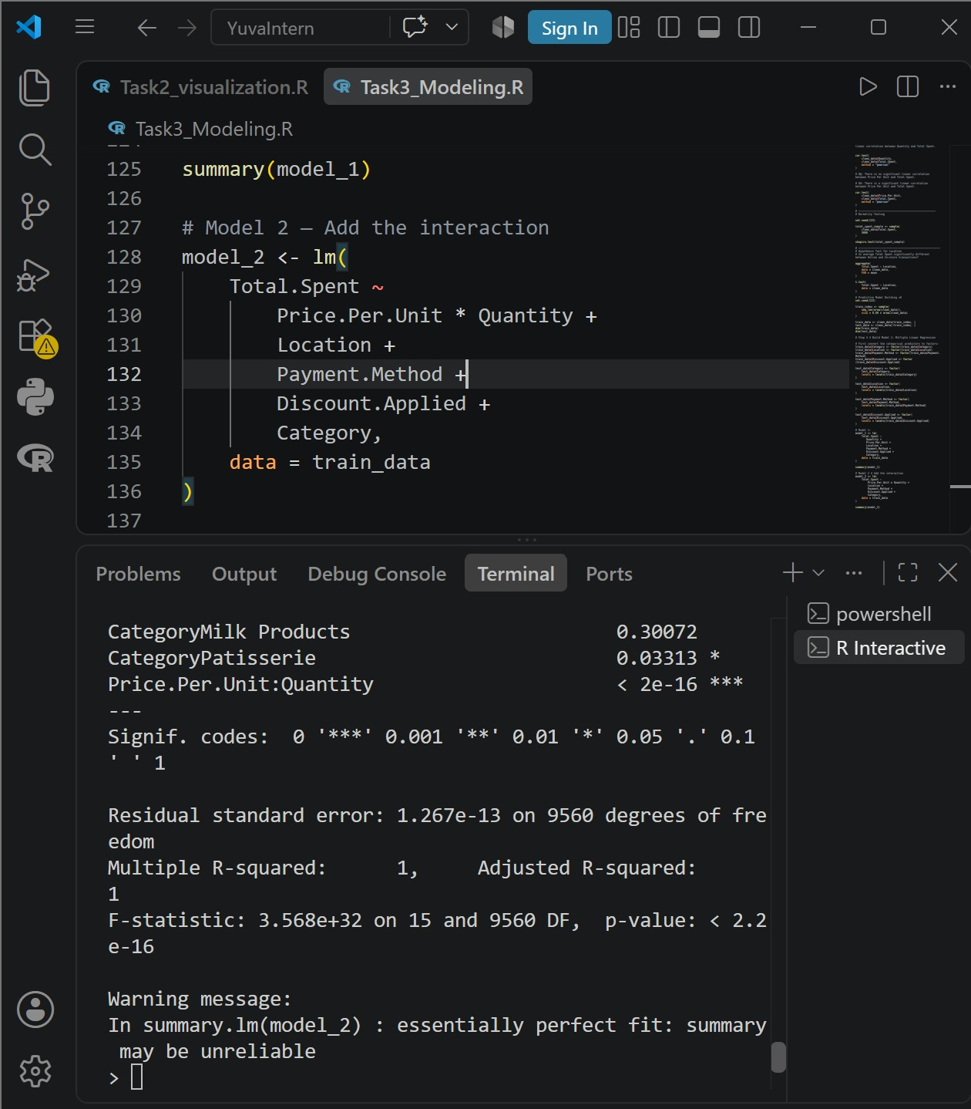

13. Model 1 vs Model 2
Both models were evaluated on the unseen test dataset.
The results were:
Model | RMSE | MAE | R²
Model 1 – Additive | 30.9746 | 23.1266 | 0.8935
Model 2 – Interaction | ≈ 0 | ≈ 0 | 1.0000
Model 2 produced essentially zero prediction error.
However, this improvement was caused by inclusion of the exact multiplicative relationship between Price Per Unit and Quantity.
Consequently, Model 1 provides the more informative assessment of ordinary predictive performance, whereas Model 2 is useful for demonstrating how model specification and feature relationships can dramatically influence model results.
This comparison also highlights why extremely high model performance should always be investigated rather than automatically interpreted as evidence of a superior predictive system.

14. Actual vs Predicted Total Spent
To visually assess Model 1 performance, actual Total Spent values from the test dataset were compared with model predictions.
prediction_plot_data <- data.frame(
Actual = test_data$Total.Spent,
Predicted = pred_model1
)

actual_predicted_plot <- ggplot(
prediction_plot_data,
aes(x = Actual, y = Predicted)
) +
geom_point(
alpha = 0.35,
size = 1.5
) +
geom_abline(
intercept = 0,
slope = 1,
color = "red",
linewidth = 1
) +
labs(
title = "Actual vs Predicted Total Spent",
subtitle =
"Performance of the additive multiple linear regression model",
x = "Actual Total Spent",
y = "Predicted Total Spent"
) +
theme_minimal(base_size = 13)
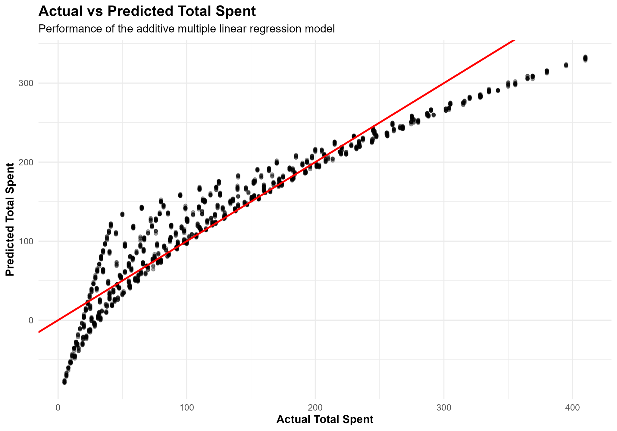
Figure 2. Actual vs Predicted Total Spent for Model 1
The diagonal reference line represents perfect predictions where:
Predicted Total Spent = Actual Total Spent
The observations broadly followed this diagonal relationship, consistent with the test R² of approximately 0.8935.
However, systematic deviations were visible, particularly toward the extremes of the transaction-value range. Higher transaction values showed evidence of underprediction.
This pattern was consistent with the residual diagnostic plots and further demonstrated that the additive specification did not fully capture the multiplicative relationship between Price Per Unit and Quantity.

15. Model Strengths
Model 1 demonstrated several strengths.
First, it achieved strong predictive performance, explaining approximately 89.35% of the variation in unseen test observations.
Second, the training, cross-validation and test results were highly consistent. This provided evidence that the performance of Model 1 was relatively stable across different data subsets.
Third, the model incorporated both numerical and categorical transaction characteristics, allowing the relative importance of different variables to be examined.
Finally, the modeling process demonstrated how statistical diagnostics can reveal weaknesses that may not be obvious from performance metrics alone. Although Model 1 had a high R², the residual diagnostics clearly identified structural limitations in its additive specification.

16. Model Limitations
Several limitations were identified.
The primary limitation of Model 1 was that it assumed an additive relationship between Quantity and Price Per Unit even though Total Spent has a multiplicative relationship with these variables.
This resulted in systematic residual patterns, non-normal residual behavior and evidence of non-constant variance.
A second limitation concerns the predictive target itself. Since Total Spent can essentially be calculated directly from Price Per Unit and Quantity, including both variables and their interaction produces a deterministic model rather than a genuinely uncertain forecasting problem.
Consequently, Model 2's R² of 1 should not be interpreted as evidence of extraordinary real-world predictive ability.
The dataset also contains transaction-level information but relatively limited customer-level behavioral information. Variables such as customer demographics, purchase history, promotions, seasonal factors and customer loyalty could potentially support more complex predictive questions if they were available.

17. Potential Improvements
Several improvements could be considered in future analysis.
First, a different predictive target could be selected that is not directly calculated from the predictors. For example, future datasets containing suitable variables could support prediction of customer purchasing behavior, repeat purchases or customer segments.
Second, additional customer-level and temporal variables could improve the ability to model behavior rather than simply transaction arithmetic.
Third, alternative predictive techniques could be compared with linear regression when working with a target that contains genuinely uncertain relationships. Examples include decision trees, random forests or other machine-learning methods.
Finally, additional external or business-context variables could potentially improve model usefulness and provide more actionable predictions.

18. Key Findings
The statistical and predictive analysis produced several important findings:
- Quantity was strongly and positively associated with Total Spent, with a Pearson correlation of approximately 0.7121.
- Price Per Unit was also positively associated with Total Spent, with a Pearson correlation of approximately 0.6306.
- Both correlations were statistically significant with p-values below 2.2e-16.
- The Shapiro-Wilk test indicated that sampled Total Spent values were not normally distributed.
- Online transactions had a slightly higher mean Total Spent than In-store transactions, but the difference was not statistically significant (p = 0.3677).
- The additive multiple linear regression model achieved a test R² of approximately 0.8935, RMSE of 30.97, and MAE of 23.13.
- Ten-fold cross-validation produced an average R² of approximately 0.8956, demonstrating stable predictive performance across folds.
- Regression diagnostics revealed systematic residual patterns, departures from residual normality and evidence of heteroscedasticity.
- Cook's distance did not indicate that a small number of individual observations were responsible for the model's overall behavior.
- Adding the interaction between Price Per Unit and Quantity produced an essentially perfect fit because Total Spent is deterministically related to their product.
- The comparison between Model 1 and Model 2 demonstrated the importance of understanding how target variables are constructed before interpreting predictive-model performance.

19. Conclusion
Task 3 extended the Retail Store Sales project from data preparation and visualization into inferential statistics and predictive modeling.
Statistical testing confirmed significant positive relationships between both Quantity and Price Per Unit with Total Spent. However, no statistically significant difference in average Total Spent was identified between Online and In-store transactions.
An additive multiple linear regression model was initially developed and demonstrated strong predictive performance. The model explained approximately 89% of the variation in unseen test data, and 10-fold cross-validation produced very similar results, indicating stable performance.
Despite the strong performance metrics, regression diagnostics revealed systematic residual patterns and violations of several standard linear-model assumptions. These diagnostics suggested that the additive model did not fully represent the underlying relationship.
The model was subsequently optimized by introducing an interaction between Price Per Unit and Quantity. This produced an essentially perfect fit because Total Spent is mathematically determined by the product of these variables.
Rather than treating this perfect performance as evidence of an exceptionally powerful predictive model, the result demonstrates an important principle of predictive analytics: model performance must always be interpreted in the context of how the target variable and predictors are constructed.
Overall, Task 3 demonstrated the complete analytical workflow from hypothesis formulation and statistical testing through model development, validation, diagnostic assessment and optimization.

